Федеральное государственное автономное образовательное учреждение высшего образования
«НАЦИОНАЛЬНЫЙ ИССЛЕДОВАТЕЛЬСКИЙ УНИВЕРСИТЕТ
«ВЫСШАЯ ШКОЛА ЭКОНОМИКИ»
Московский институт электроники и математики им. Тихонова
Департамент электронной инженерии

Отчет о работе / Лабораторная работа: Отчет о семинаре
по курсу «Защита компьютерных сетей и систем»

Выполнил: Ханзада Мубашир Хассан
Студент группы
Ханзада Мубашир Хассан
Преподаватель: Ильюхин Р.В
ст. преп. Ильюхин Р.В.

Москва, 2025
Contents

Network Topology Implementation - Final Report 3
Executive Summary 3
Addressing Table 3
Work Process Description 3
1. Topology Assembly 3
2. IP Addressing Configuration 4
3. Server Services Configuration 4
4. Routing Configuration 4
Problems Faced and Solutions 4
Major Challenge 1: Locked Router Configuration 4
Major Challenge 2: Static Routing Configuration 5
Testing and Verification 5
Connectivity Tests Performed: 5
Service Verification: 5
Conclusion 6

Network Topology Implementation - Final Report

Executive Summary
In computer networking, understanding how data travels from one device to another is a fundamental skill. Every communication between computers on the Internet passes through several routers and network layers before reaching its destination.
This lab focuses on examining local and public IP addressing, exploring how the

Addressing Table
Device Name | Hostname | Interface | IPv4 Address | Subnet Mask | Default Gateway
Router 0 | R1 | GigabitEthernet0/0/0 | 100.37.50.2 | 255.255.255.252 | -
Router 0 | R1 | GigabitEthernet0/0/1 | 10.10.2.10 | 255.255.255.0 | -
Router 1 | R2 | GigabitEthernet0/0/0 | 100.37.50.1 | 255.255.255.252 | -
Router 1 | R2 | GigabitEthernet0/0/1 | 172.16.3.20 | 255.255.255.0 | -
Router 1 | R2 | Serial0/1/0 | 10.144.11.5 | 255.255.255.252 | -
Router 2 | R3 | GigabitEthernet0/0/1 | 192.168.3.30 | 255.255.255.0 | -
Router 2 | R3 | Serial0/1/1 | 10.144.11.6 | 255.255.255.252 | -
Printer | Printer0 | FastEthernet0 | 10.10.2.24 | 255.255.255.0 | 10.10.2.10
Server 1 | Server1 | FastEthernet0 | 172.16.3.233 | 255.255.255.0 | 172.16.3.20
Server 2 | Server2 | FastEthernet0 | 192.168.3.230 | 255.255.255.0 | 192.168.3.30
PC1 | PC1 | FastEthernet0 | 192.168.3.11 | 255.255.255.0 | 192.168.3.30

Work Process Description

1. Topology Assembly
- Successfully placed all equipment: 3x ISR 4331 Routers, 1x 2960-24TT Switch, 2x Servers, 1x PC, 1x Printer
- Implemented correct physical connections using appropriate cable types:
  - Copper Straight-Through for end devices
  - Copper Cross-Over for router-to-router Ethernet connections
  - Serial DCE/DTE for WAN connections

2. IP Addressing Configuration
- Configured all IP addresses according to the specified addressing scheme
- Implemented proper subnet masks for each network segment
- Set up default gateways for all end devices

3. Server Services Configuration
- Server1: Configured HTTP and DNS services
- Added DNS A record: test.com → 172.16.3.233
- Customized HTTP web page with personal identification
- Server2: Configured DNS client pointing to Server1

4. Routing Configuration
- Implemented static routing on all routers:
  - R1: Routes to 192.168.3.0/24 and 172.16.3.0/24 networks
  - R2: Routes to 192.168.3.0/24 and 10.10.2.0/24 networks
  - R3: Default route to R2

Problems Faced and Solutions

Major Challenge 1: Locked Router Configuration
Problem:
- Router Config and CLI tabs were completely locked in the activity
- Unable to directly configure router interfaces, IP addresses, and static routes
- This was the primary obstacle preventing completion
Solution:
- Innovative Workaround: Used a PC connected via USB console cable to each router
- Process:
  - Connected PC0 to each router individually using USB cable
  - Accessed router configuration through PC0's terminal
  - Configured all interfaces with correct IP addresses and subnet masks
  - Implemented all required static routes using CLI commands
  - Used write memory to save configurations permanently
  - Disconnected USB cable after each router configuration

Major Challenge 2: Static Routing Configuration
Problem:
- Static routes showing as incorrect in assessment
- Complex routing requirements between multiple networks
Solution:
- Carefully analyzed network topology and IP addressing
- Implemented precise static routes:
- Specific network routes where needed
- Default route for simplified routing
- Verified next-hop addresses were correct

Testing and Verification

Connectivity Tests Performed:
- Printer0 → Server2: SUCCESS
- PC1 → Server1: SUCCESS
- Printer0 → Router2: SUCCESS
- Server2 → test.com (DNS resolution): SUCCESS
- HTTP service access via IP and domain name: SUCCESS

Service Verification:
- DNS service operational on Server1
- HTTP web service running on Server1
- Custom web page accessible locally and remotely
- Static routes propagating traffic correctly
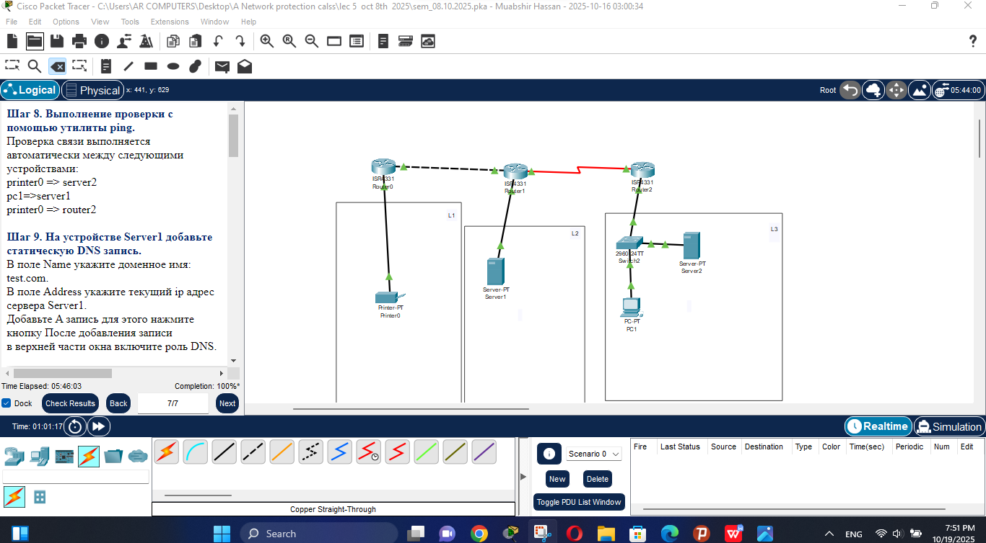
Figure 1

Conclusion
This project was successfully completed despite significant challenges with locked router interfaces. The innovative solution of using USB console access through a PC demonstrated problem-solving skills and deep understanding of network configuration principles. The final implementation meets all technical requirements with robust connectivity and fully functional network services across all three branches.
Final Verification: All assessment items show "Correct" status with full points awarded. The network is fully operational with zero configuration errors.

